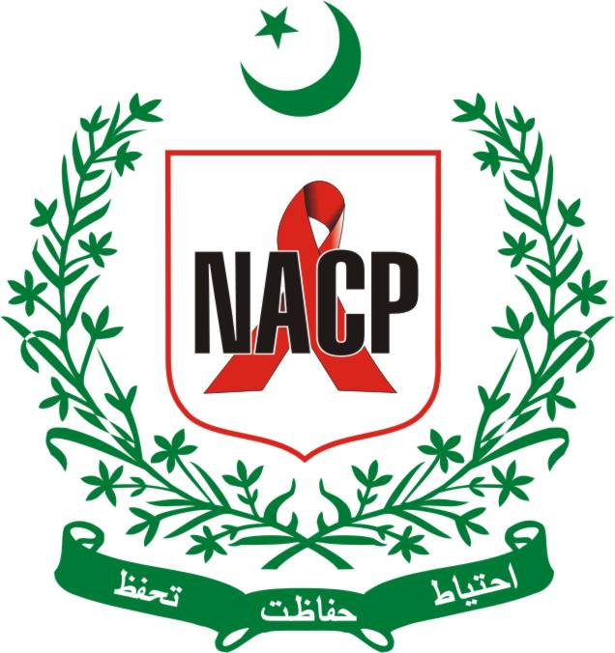
Common Unit to Manage GFATM Grant for HIV, T.B and Malaria

Office of the Principal Recipient – The Global Fund (NFR Grant)

Ministry of National Health Services Regulation & Coordination; Islamabad

Expression of Interest (EOI) application form
EOI No. 002/2019

I-Development of SOPs and Guidelines for Case Manager(s) based at ART (HIV Treatment) Centre. II-Development of SOPs of Counselling at ART Centres

Key requirements:

- Completed EOIs must be submitted through courier till 11:00 am April 05, 2019.
- Applicants should submit all documents included as part of the submission should be in Arial/Calibri, 12 pt, in single spacing
- Applicants should observe the word limit; additional words outside the limit will be disregarded.

EOIs/Application(s) review schedule:

Stage | Date
EOIs to be received by | April 05, 2019
Evaluation of EOIs | 05-08 April 2019
Issuance of RFP to shortlist applicants | 09 April 2019

Short listing criteria for EOIs
(Consultant)

S# | Particular | Max. Points
A | Qualification | 18
 | MBBS with MPH  MBBS=10 Marks, MPH= 8 Marks (3years post MPH experience) | 18
B | Experience in Public Health Consultancy (05 marks / project) | 30
 | 1-2 consultancies | 10
 | 3-5 consultancies | 25
 | 6 and above | 30
C | Work Experience in HIV/AIDS related projects (07 marks/project) | 42
 | 1-2 project(s) | 14
 | 3-5 project(s) | 35
 | 6 and above project(s) | 42
D | Similar Work Experience to develop guidelines and SOPs | 10
 | Guideline(s) developed =5 | 5
 | SOPs developed =5 | 5
 | Total (A+B+C+D) | 100
 | Minimum Marks required for qualification | 60

Information about the applicant:

Name of Applicant:
Full postal address, including country:
Website (if any):
Email:
Phone:

2- Please provide detail of each consultancy (completed) as per following table. Please use one table for each project. You can add more table as per need:

Consultancy name:
Duration:
Geographical location / country of the project/consultancy:
Funding organisation/client:
Contact details of a reference at the funding organisation:
Relevance to this consultancy in terms of technical area with this EOI | 300 words max

3- Please provide detail of HIV/AIDS related projects(completed). Please use one tablet for each project. You can add more table as per need:

Consultancy/Project name:
Duration:
Geographical location / country of the project/consultancy:
Funding organisation/client:
Contact details of a reference at the funding organisation:
Relevance to this consultancy in terms of technical area with this EOI | 300 words max

3- Additional capacity statement:

Please include additional information to highlight your capacity to deliver NACP CMU PR-GFATM in this consultancy:

Maximum words: 1000 words

4- Similar work experience in the development of guidelines and SOPs :

Tile of guidelines/SOPs:
Date of development:
Funding organisation/client:
Please provide one copy of any one guideline and SOP

5- Required documents:

- Filled EOI Application Form
- Update Resume

Note: Two set of above documents must be sealed in envelope clearly mentioning “EOI No. and title of the consultancy

6- Method of procurement:

The consultant will be selected as per PPRA Procurement of Consultancy Services Regulations 2010, under the fixed budget consultancy E I &II
7- Annexure:

  - TORs for Case Manager Guidelines and SOPs.
  - TORs for Counselling SOPs.

Above TORs are uploaded separately at www.nacp.gov.pk and part of this document.

