summary of recommendations to effectively address the rising hiv epidemic in pakistan
HUMAN RIGHTS CASE 25819-9 OF 2018
August 23, 2018

BACKGROUND & INTRODUCTION:
In the background of Jalalpur Jattan case (2008), hearing was held in Supreme Court on August 3rd 2018 and committee was formed under the leadership of Dr. Baseer Khan Achakzai, National Programme Manager, NACPincluding eight other members from provincial AIDS control programs , APLHIV, NAiZindagi, CSOs members and three UN agencies including UNAIDS, WHO and UNDP as co-opted members. The terms of reference were devised and these were mentioned as followed:

- Expansion of quality preventive and treatment services for Key Populations across Pakistan
- Non-stigmatised and evidence-based awareness campaign through print,
- Enabling environment in the light of basic human rights implementation
- To strengthen the mechanism of monitoring and evaluation of HIV services, preventive services as well as curative services and care.
- To review all the Provincial AIDS Strategy and set recommendations.

Meeting was held on 20th August in National AIDS Control Programme, where it was decided to populate a matrix against each point of term of reference with gaps and recommendation with timelines and responsibilities to address the reoccurrence of such grave epidemiological issues in the country.
Overview of HIV Epidemic and Response:
- Around 150,000 Pakistanis are estimated infected with HIV, the virus that causes AIDS, as per the recent HIV modelling;
- Every year there are estimated 20,000 new HIV infections. The available evidence indicates that HIV is spreading very rapidly in the country with 45 % of increase in new infection from 2010-2017.
- Only 7% are receiving life-saving anti-retroviral therapy (ART). This is the lowest treatment coverage in Asia and the Pacific.
- ART primarily keep people living with HIV in good health. There is also evidence now to support the benefits of ART in reducing HIV transmission.
- Without taking ART, onward transmission continues and more Pakistani, especially young people, will likely be infected.

Low TESTING and treatment coverage (7%) is a result of, among others, the following factors:

- Low prevention and testing programme coverage among key populations, and other vulnerable populations,
- Unaddressed barriers to testing, treatment access, initiation and adherence
- Relatively high dropout rates among people on treatment and a relatively poor patient monitoring system;
- Weaknesses in the national monitoring and evaluation system
The recommendations from the Pakistan AIDS Strategy includes:
- Addressing needs of PWIDs to bring them towards treatment access and retention
- Scaling up prevention programmes targeting sexual transmission
- Integrate HIV testing Services (HTS) for KPs and their spouses
- Community led and community based programme models
- Initiate Test All strategy, for HIV cases identified
- Integrate treatment adherence support for PLHIV from KP community based to ensure continuum of care
- Serious efforts to address treatment barriers faced by KPs such as stigma and discrimination
- Strengthening monitoring and evaluation
Below are relevant strategic information:
Key population | Size estimate | HIV prevalence | PLHA | Programme coverage
People who inject drugs (PWIDs) | 113,422 | 38.4% | 43,554 | 17.6%
Hijra sex workers (HSW) | 42,190 | 7.5% | 3,164 | 14.9%
Non sex worker men who have sex with men (Non SW MSM) | 776,873 | 3.4% | 26,414 | 3.5%
Female sex worker (FSW) | 173,447 | 2.2% | 3,816 | 7.9%
Male sex worker (MSW) | 55,340 | 5.6% | 3,816 | 16.6%

Targets as per the Pakistan AIDS Strategy 2017-2020:
Key population | Baseline 2017 | 2018 | 2019 | 2020
# of syringes and needles distributed per PWID in last 12 months | 51 | 147 | 197 | 200
% of PWIDs reached by HIV prevention programmes in last 12 months | 18% | 37% | 44% | 51%
% of non SW MSM reached by HIV prevention programmes in last 12 months | 4% | 14% | 19% | 25%
% of MSW reached by HIV prevention programmes in last 12 months | 15% | 34% | 43% | 53%
% of HSW reached by HIV prevention programmes in last 12 months | 17% | 35% | 44% | 52%
% of FSW reached by HIV prevention programmes in last 12 months | 8% | 25% | 33% | 42%

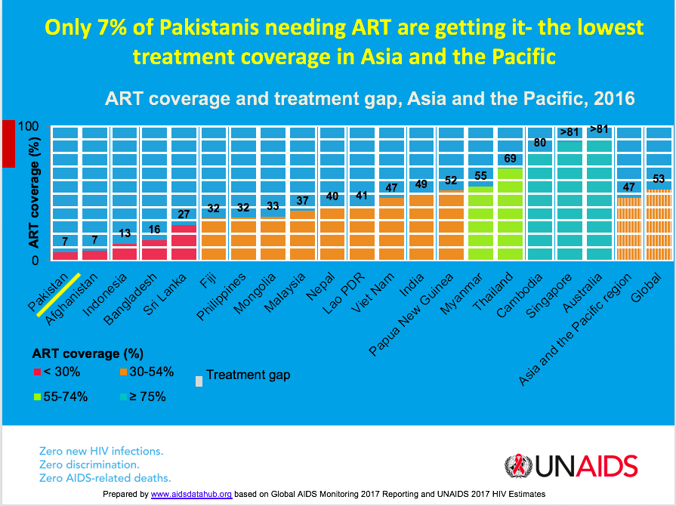

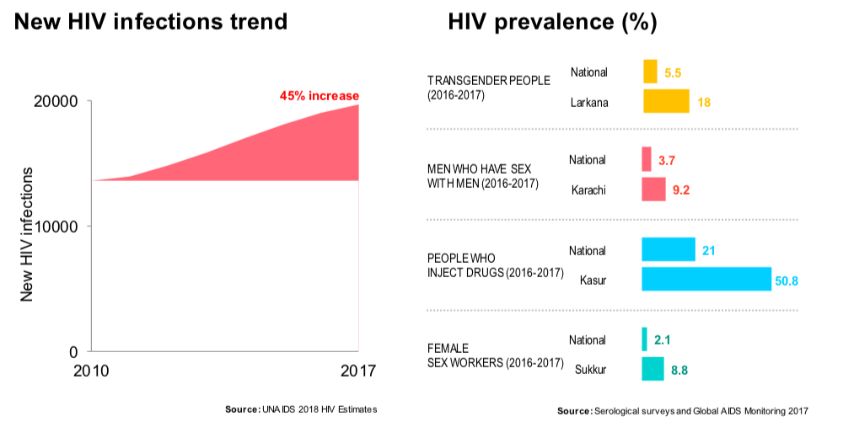

Gaps | Recommendations | Responsibilities and Timelines | Cross Cutting Recommendations
TOR-I: REVIEW ALL PROVINCIAL (PLUS PASIII 2017-2021) & SET RECOMMENDATIONS
TOR-II: EXPANSION OF QUALITY PREVENTION & TREATMENT SERVICES FOR KEY POPULATION ACROSS PAKISTAN
Low prevention and testing programme coverage among key populations | - Uninterrupted services should be ensured and there should be a sustainable mechanism which is programme based rather project based services. Fast track PC1s approach is required. Robust implementation mechanism with quarterly monitoring is required. Service delivery for KPs at prioritized cities and KP as per the PAS III  - A ramped up investment in community-based HIV Testing Services (HTS) should be delivered in community settings and by community members and the CBOs serving them.  - Testing and treatment coverage should be inclusive of partners and spouses, as appropriate, with a particular focus on the early identification of pregnant partners and spouses. Pakistan’s new strategic framework for the prevention of parent to child transmission of HIV (PPTCT) recommends targeted “demand generation” in key populations with PWID and their spouses as a first priority  - PrEP should be made available to key populations  - Availability of ARVs through domestic resources can also be looked into as funds were allocated to procure ARVs both in PC1s of Punjab and Sindh. However probably in future manufacturing of the ARVs locally also needs to be seriously considered and WHO and Federal Ministry can look into. , | NACP & PACPs by Last quarter of 2018 and 1st quarter of 2019 before next PC1 development at federal and provincial level | - Quarterly 02 days programme meetings where federal and provincial programmes along with CSOs, UN partners can review progress on targets and service delivery  - Rigorous monitoring of Pakistan and Provincial AIDS Strategies are required with operation timelines including communities and APLHIV so that targets are met to achieve three 90s.  - Technical Advisory Committee on HIV and AIDS (TACA) should be revived  - Provincial Task Forces on HIV should be made functional
The continued existence of treatment barriers access and initiation, treatment &attrition rates, especially among PWIDs. | - Opiate Substitution Therapy (OST) will be game changer should be initiated as soon as possible if possible if Supreme Court can order its initiation along with Harm Reduction services  - Active involvement of community-based case managers and strong communication links between these community workers and clinic staff. | NACP & PACPs, APLHIV, CSOs along with technical support of UN partners at earliest basis
Access to treatment in terms of distance has emerged as one of the critical issues related to HIV prevention efforts. (one of the many reasons that facilities are not available at doorsteps and people go to quacks) | - To ensure expansion of quality & sustained treatment services, there is a need to have well equipped decentralized / differentiated ART Centers. These centers must be equipped with required human and technical skills as per national protocols. Right people for the right job are required.  - Strict rules and regulation and their implementation against quacks and unauthorized health clinics is an incomplete agenda in AIDS response, which must be addressed on war footing to avoid reoccurrence of Jalalpur Jattan case;  - Strict enforcement of Injection safety, hospital waste management and infection control measures | PACPs to operationalize PC1 and its ongoing process
Service delivery packages providing services in the provinces are limited and sometimes even are not available- no national standardized guidelines protocols/ SoPs for Service Delivery Packages for Key Populations | - Service delivery models should be tailored to the community settings particular to each key population. Where possible, testing services are to be integrated into existing community led/based prevention programmes that address behavioral risk.  - National guidelines/SoPs should be developed for comprehensive service delivery packages should be develop. Along with these services need to be sustained through domestic resources. Currently across the country the services are being provided only through GF grant. The provinces need to implement provincial Strategies in true spirit and litter. Government ownership at federal and provincial level is required.  - Community engagement need to be ensured at every level and their capacities need to be strengthened for provision of services  - Increase the number of service outlets in identified prioritized / high risk districts, with active engagement of CBOs | NACP, PACPs & APLHIV, CBOS through technical support of UN partners by Last quarter of 2018 | Community engagement need to be ensured at every step
Except for PWIDs, there is no service delivery for any other key population except under GFATM grant and even in Punjab since 2016 these services (including HIV Prevention and testing services in KPs, care and support services for PLHA are not available) are not available. Even in rest of the provinces through PC1s or other domestic resources no services are available for any KP. Services are available only through GF grant. PC1 are available but releases are not on time and in full as per approved budgets, which needs to be highlighted. | Service delivery packages approved under the PC1s need to implemented and monitored on urgent basis. , | PACPs to operationalize PC1 and its ongoing process
Funds are not being released on time for PC-1s and if released then not implementation due to (amount reduced from what agreed in PC-1) | - Robust advocacy with relevant decision makers (P&D) for timely releases of PC-1s  - Timely execution of provincial strategies and release and implementation of funds under PC1s has always been an issue. The provincial programs need to be more assertive in their provinces in this regard. Services under PC1s need to be in line with AIDS Strategies and through a transparent process. Identified KPs as per HIV prevalence and available evidence need to be targeted.
Weak institutional capacities at federal and provincial level to fastest growing HIV response | Strong institutional capacity to ensure implementation of Provincial and National Strategies and programs. NACP as an umbrella organization at the National level needs to be strengthened with enhanced mandate, role, responsibilities and capacities. Technical capacity of Provincial Programs in terms of implementation, monitoring, evaluation, data management and directing the resources in right direction needs to be enhanced. . | NACP & PACPs through technical support of UN partners between last and 1st quarter of 2019
TOR 3: ENABLING ENVIRONMENT IN THE LIGHT OF BASIC HUMAN RIGHTS IMPLEMENTATION
TOR 4: NON-STIGMATISED & EVIDENCES BASED AWARENESS CAMPAIGN THROUGH PRINT ELECTRONIC & SOCIAL MEDIA
As per IBBS 2016-2017 Stigma & Discrimination against Key Population is:  63.8% of People who inject drugs (PWIDs) reported having faced discrimination  35.6% Female sex workers reported being discriminated against  55% of female sex workers interviewed from kothikhana (brothel houses) reported of been physically injured or hurt.  50% MSWs reported discrimination as comparative to non-sex workers MSMs.  55.8% transgender sex workers reported being discriminated in comparison to non-sex workers transgender. | - National and provincial framework on reduction of stigma and discrimination should be development in health care settings  - Ethical committees should be established in hospitals specially where ART clinics are established including CBOs and KPs representative to monitor stigma and discrimination  - Redressal Mechanism for reporting any incidence of Stigma & Discrimination | - NACP & PACPs APLHIV, CSOs, through technical support of UN partners by Last quarter of 2018  - NACP & PACPs APLHIV, CSOs, through technical support of UN partners by 1st quarter of 2019.
Lack of effective implementation of already passed HIV Act and passing pending bills | - Implementation of the only passed HIV Act (Sindh) to set the precedence for other provinces  - Pending HIV bill in Punjab and ICT needs to be passed  - Implementation Watch Committee need to be formed to monitor the progress of legislation and to create enabling environment  - Transgender Bills passed at national level needs to be implemented in letter and spirit. . | NACP & PACPs through APLHIV, CSOs, technical support of UN partners between last and 1st quarter of 2019
Lack of any effective media campaign that can engage policy makers, opinion makers, parliamentarians on regular basis | - Development of communication strategy  - Engagement of parliamentarians through SDG Task Force  - Training of religious leaders, health care providers  - Effective us of APLHIV helpline  - MoU with Ministry of Information& PEMRA on having continuous HIV related awareness messages and also have air time dedicated under public service.  - APLHIV must be supported to enhance its advocacy skills  - Health and law enforcement professionals need to be educated in order to reduce S&D and marginalization to promote access to rights based services. Punitive policies and interventions | NACP, PACPs, APLHIV, CSOs, through technical support of UN partners between last and 1st quarter of 2019  NACP, PACPs, APLHIV, CSOs, through technical support of UN partners between last and 1st quarter of 2019

TOR 5: STRENGTHEN THE MECHANISM OF MONITORING AND EVALUATION OF HIV SERVICES, PREVENTION SERVICES AS WELL AS CURATIVE SERVICE AND CARE
Weak monitoring and evaluation system | - Review of national M&E system is required to make it into one national M&E system rather disintegrated system  - Monitoring of community-based testing coverage: the current system only tracks the testing that is done when people register at treatment centres. With the bulk of testing moving into community settings the purview of the monitoring and evaluation system needs to be extended into those settings.  - Adherence monitoring / Patient Monitoring: the new emphasis on adherence support needs a system that allows for easy analysis of differing adherence and loss to follow up rates among PLHA from different key populations.  - Viral load monitoring: at present there is very limited data available about viral suppression. This will need to be addressed if the treatment programme is to be able to assess its impact.  - A strong mechanism of accountability needs to be in place to ensure that the resources available are being used as per available evidence at the right place and in right direction through a transparent system with required/expected results being ensured. Role of APLHIV in monitoring should also be strengthened. | NACP, PACP, APLHIV through technical support of UN partners between 2018 and 1st quarter of 2019
Prevention MIS Does not exit. | - Establish Prevention HIV cascade, create synergies with DHIS2, Agree on routine joint monitoring of prevention targets through Provincial Multi-Stakeholder Task Force | NACP, PACP, APLHIV through technical support of UN partners between 2018 and 2nd quarter of 2019

Description | Resources Requires to address Prevention Targets | Prevention Financing
National Strategic Plan include a set of prevention targets in line with the 2015 UNAIDS Strategy and Political Declaration. | Because of resource constraints and low baseline targets it was decided after national consensus that this will be addressed as “high impact” and not as “fast track” targets*  * USD 509 million are needed for fast track where as high impact required 265 million for 2017-21 period most of which will go to prevention;  Pakistan’s AIDS kitty does not have 509 million but through GFATM & PC1s there are 66 millions USD available and Pakistan is deficit of 199 million  Coverage from National Strategic Plan for 2018-2020 period:  PWIDs: 37-51%  Non SW MSM: 14-25%  MSW: 34-53%  TGSW: 35-52%  FWS: 25-42% | USD required for 2018-2020 period  PWIDs: approx. 9-12 million USD  Non SW MSM: approx. 15-33 million  MSW: 2-3.8 million  HSW: 2.5-3.8 million  FSW: 5.6-12 million  PLHIV: 5.6-12.3 million  Programme Management: 5-600K  PrEP: 154-308K  OST: 251-628K  Evaluation: 50K
Estimation of program/finance) gap against the targets | For 2018-20 period  MSM: GF covers 2-4%; domestic & other 6-9%; annual gap 95-96%  PWIDs: GF covers 10-11%;domestic & other 10-11%; annual gap 89-90%  TGs: GF covers 10-14%; domestic & other 56-83%; annual gap 34-3%*  PLHA and support: GF covers 5-6%; domestic & other 3-6%; annual gap 94-96%

Pakistan AIDS Strategy (PAS) III 2017-2021
Current (2016) treatment coverage for HIV positive pregnant women is estimated at 5.3%. A new strategic framework has been developed for prevention of parent to child transmission (PPTCT) of HIV in Pakistan and recommends scaling up PPTCT services “to particularly reach and provide services to key populations, the most marginalized groups and those affected by HIV/AIDS.” See p15, Strategic Framework for PPTCT of HIV in Pakistan, UNICEF, December 2016.
PAS III 2017-2021
Punjab AIDS Strategy 2017-2021
PAS III 2017-2021
AIDS Epidemic Modelling 2017

