Human Rights Case No. 25819-P/2018
(Jallalpur Jattan AIDS victims)
Committee Recommendations

Table of Contents

Table of Contents 1
Background: 2
Introduction: 2
Overview of the National HIV Response & Current Implementation Arrangements: 3
Human Rights Case No. 25819-P/2018 (Jallalpur Jattan AIDS victims) 8
Recommendations 11
Conclusion 13

Background:
Jalalpur Jattan is a Tehsil of district Gujrat in the Punjab province of Pakistan. According to 1998 Census, the population of the tehsil is around 343, 834 with an area of 96,212 acres.

In June–July 2008 a non-governmental organization (NGO) in Jalalpur Jattan (JPJ), Gujrat, arranged two HIV screening camps. Two hundred and forty-six (246) individuals screened 88 were found HIV positive on the recommended WHO three test protocol and referred to the ART center Lahore. The Pakistan Field Epidemiology Training and Laboratory Training Program (FELTP) investigated the outbreak and found infected therapeutic use (use of same syringe on multiple patients by quacks) to be the source of infection.

A case had been filed in the Supreme Court on the subject matter whereby the Supreme Court remarked: “The issue of AIDS is not confined only to the province of Punjab; rather, it extends to the whole Pakistan. Therefore, we require reports as to what preventive and curative steps have been taken, including the promotion of awareness.”

Introduction:
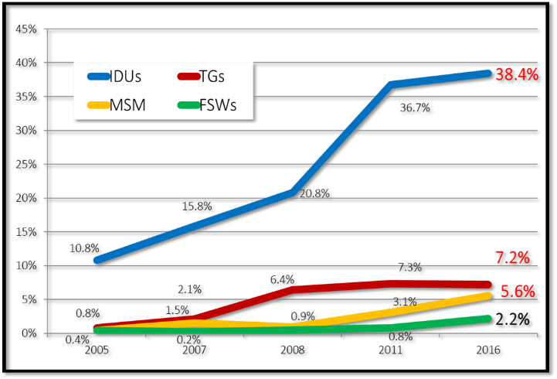
Pakistan is following a comparable HIV epidemic trend having moved from ‘low prevalence, high risk’ to a ‘concentrated’ epidemic in the early to mid-2000s. The epidemic is concentrated among key populations (KPs) namely People Who Inject Drugs (PWID), Men Who have Sex with Men (MSM), Transgenders (TGs) and sexual workers (male, female and transgender). HIV prevalence in the general population remains less than 0.1% but epidemiological evidence from the latest surveillance round (IBBS-2016) suggests a shift in geographical trends of key populations from major urban cities and provincial capitals, to smaller cities and peripheries as well as increase number of cases in the bridging and vulnerable populations.

An in-depth review of the progression of the HIV epidemic in the country shows that Pakistan HIV epidemic is following the trends as outlined by Asian Epidemic Modelling, whereby the HIV infections start in injecting drug users and ultimately spread to the general population through sexual networks. Similarly, Pakistan is following the same trend where the HIV epidemic started in injecting drugs users as seen in the graph above and then started spilling over into sexual networks and will continue to spread into the general population if strong preventive measures are not put in place urgently.
The Asian Epidemic Modelling has been modelled in Pakistan by HIV modelling experts. The model suggests that the infection will continue to rise in sexual networks (MSM, TGs, FSWs, MSW) till the year 2030 before spreading to the general population (shown in the Diagram-2).

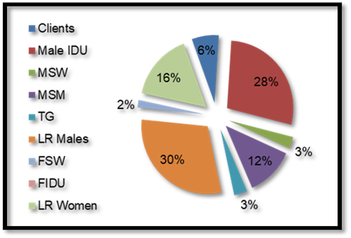
A thorough review of the Pakistan HIV epidemic shows a steady increase in HIV infections in PWIDs from 10.8% in 2005 to 38.4% in 2016 whereas in sexual networks the epidemic rose from less than 0.1% in 2005 to 7.2%, 5.6% and 2.2% respectively in Transgenders, Men who have Sex with Men and Female Sex Workers in 2016. According to up-to-date epidemiological evidence an estimated 20,000 new HIV infections were added to the pool of PLHIV in the country in 2016-17 of which 28% of the new infections occurred in PWIDS, 12% in MSM, 3% in TGs and 2% in FSW. A significant percentage of low risk males, females and clients of KPs were newly infected suggesting an increase in HIV transmission to bridging populations (spouses, partners and clients) of key populations.

Overview of the National HIV Response & Current Implementation Arrangements:
In response to the growing HIV epidemic in the country, the National AIDS Control Programme (NACP) with the support of development partners developed its first national strategy framework in 2001 that culminated in establishment of first response called Enhanced HIV and AIDS Control Project. The initial response focussed on lab-based HIV testing and ended in 2008. This was followed by the 2nd National Strategic Framework that was more focussed and included HIV prevention and testing interventions for Key Populations. The HIV response evolved according to the epidemiological evidence generated from the 05 surveillance rounds that were conducted in the country to provide up to date evidence for strategic guidance and programming. The country then developed the 3rd Strategic Framework 2015-20 that focussed on quality HIV treatment and care services. The 3rd Strategic Framework 2015-20 was revised to cover the period from 2017 to 2021 in light of the recent IBBS-2016 round and the AIDS Epidemic Modelling workshops.
NACP redefined its approach to countering the HIV epidemic in the country by adopting a new strategy which consists of high impact interventions in the highest burden districts of the country while continuing providing comprehensive HIV prevention, diagnostic and treatment services to most at risk populations and people living with HIV.
The fifth surveillance round was conducted in 23 cities of Pakistan in 2016 on the basis of which key population specific population size estimates and HIV prevalence was determined. Based on these results city prioritization for each key population was done for future programming. NACP in consultation with development partners, relevant stakeholders and representatives of the target communities developed evidence supported HIV prevention packages for each key population and target setting for a high impact response in line with the global UNAIDS 90-90-90 HIV specific goals.
Review of data (IBBS-2016) indicated that increase in HIV infections can be attributed to low uptake of preventive services by key populations, unprotected sexual practices, and
Key Population | Condom Use | HIV Preventive Services Utilization
PWID | 15.8% | 24.6%
TG/TGSW | 13.1% | 15.1%
FSW | 38% | 8.3%
MSM/MSW | 8.6% | 13.3%

(Source: IBBS-2016)
needle sharing among PWIDs. Interactions between various key populations further increase the risk of spill over of Infection from one group to another. Therefore, the current high impact scenario was devised with focussed precision targeted KP-specific interventions based on cost effective high yield best practices with the ultimate aim to control the spread of HIV in the country.
After devolution in 2011, the Provinces mobilized their own resources for providing preventive and treatment services to the HIV infected and at risk populations. Currently, Pakistan has approved provincial and national PC-1s for HIV AIDS. In addition, to the resources committed by the government of Pakistan, the country has also been a recipient of Global Fund grants since 2004. National AIDS Control Programme and Nai-Zindagi (NZ) are the Principle Recipients of the grant with distinct objectives and provide comprehensive preventive services to their respective target populations. NACP provides free of cost HIV diagnostic and treatment services to all populations. The Provincial AIDS Control Programmes acts as sub-recipients (SRs) of the grant to implement program activities in the provinces.
The HIV epidemic in Pakistan is slowly spreading out its tenacious roots with serious social, economic and health consequences. Pakistan is confronted with enormous challenges for implementing the HIV response. HIV and AIDS is intrinsically linked with key populations, risky human behaviours and disease associated stigma and discrimination. Limited resources, both human and fiscal, low uptake of HIV preventive and treatment services, limited scope and coverage of HIV interventions, donor steered and supported programming, lack of HIV knowledge, community denial and receptiveness to uptake of HIV services, fear of punitive actions by law enforcement agencies and social marginalization are some of the challenges faced by policy makers and implementers while implementing key interventions.
During the development of the strategic framework (2017-2021) a thorough exercise of gap identification with appropriate mitigation measures was done through a review of all program interventions. In-depth consultations with provincial programmes, stakeholders, development partners, members of the key population communities, representations of civil society and Association of people living with HIV (APLHIV) were conducted. The national response was strategically designed making use of up to date epidemiological evidence and included review and revision of the National and Provincial AIDS Strategies, adoption of recommended key population specific HIV prevention packages, introduction of a community led HIV prevention model and implementation of WHO treatment for all guidelines. The strategic framework given below defines the salient features of the national response.
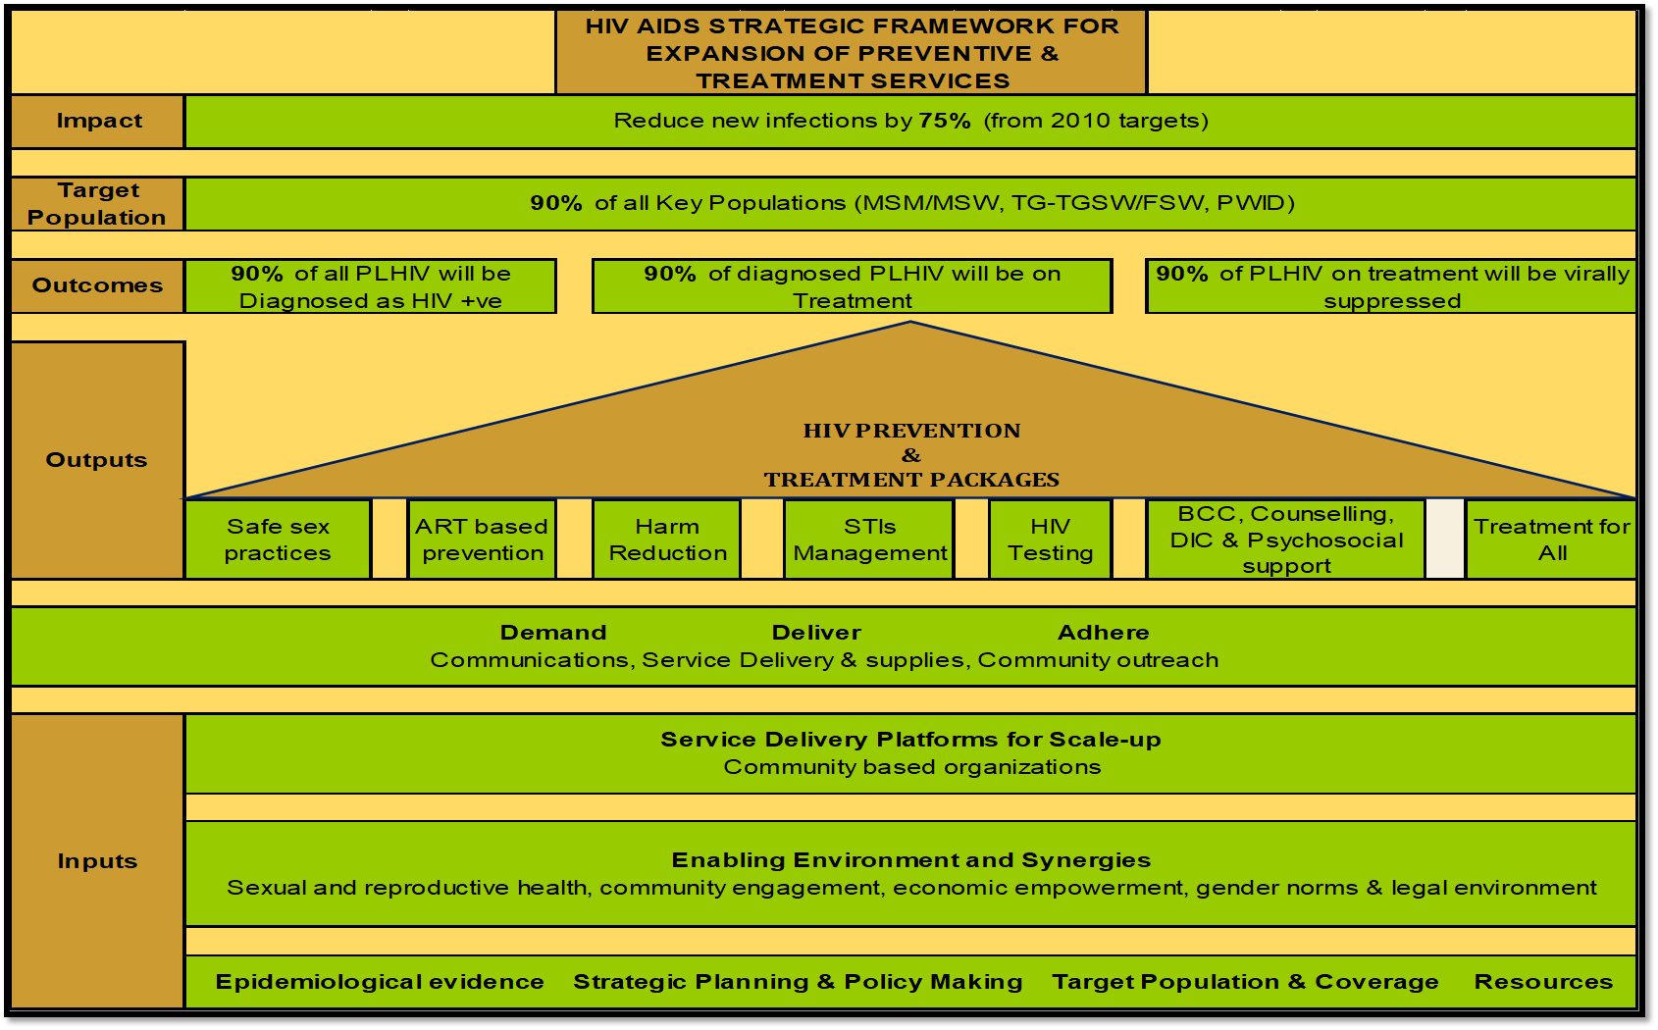
In wake of the changing disease trends and recent evidence the National program is implementing a community-based HIV prevention model in target cities with pre-defined HIV prevention packages for each target key population. Furthermore, decentralization of HIV treatment centres has been done based on HIV patient mapping for increasing the coverage of HIV diagnostic and treatment services and addressing access and availability issues. The numbers of treatment centres across the country continue to rise to reach HIV positives spread across the country.
- Key Population specific HIV Prevention Packages
A comprehensive literature review was done to formulate evidence supported, internationally recommended best practices-based HIV prevention intervention for each of the specific key populations. These interventions were contextually analysed for appropriateness and acceptability and endorsed by the respective communities for incorporation into the national and provincial strategies for implementation.

Intervention Package for PWID
- NSEP Services: Provision of new syringes, needles, band-aids and alcohol swabs; collection of used syringes and needles; provision of condoms; provision of hygiene services; behavior change communication messages on HIV, safe sexual practices, safe injecting practices and STIs.
- HIV Testing & Counseling for PWID and spouses.
- Spouse Prevention Program: Provision of condoms, counseling on HIV and safer sexual practices, provision of living support package, referral to PPTCT centers.
- Referral to ART and adherence support.
- STI diagnosis and treatment.
- Paramedic and Basic Medical Care: Antiseptic dressing for wounds and abscesses,
- Referral to private medical practitioners for basic medical care.
- ART Adherence Unit: residential care for 8 weeks for detoxification, initiation and maintenance on ART and adherence support.
Intervention Package for MSM/MSW
- Behavioral change communication through outreach (includes Condom & Lubes, IEC material)
- Drop In Center facility (for repeat BCC /Psycho social support & Counselling)
- VCCT with pre & post counselling & psychological counselling (community-based HIV testing)
- STI diagnosis & Treatment
- Referral support to PLHIV clients with strong follow-up
- Condoms & lubes distribution
- Career counselling and family counselling in DIC.

Intervention Package for HSW
- BCC - Behavioral change communication through outreach (includes Condom & Lubes, IEC material)
- Drop In Center facility (for repeat BCC /Psycho social support & Counselling)
- VCCT with pre & post counselling & psychological counselling (community-based HIV testing)
- STI diagnosis & Treatment
- Referral support to PLHIV clients with strong follow-up
- Condoms & lubes distribution
- Career counselling and family counselling in DIC

Intervention Package for FSW
- Establishment of Drop-In Centers (DIC) to deliver services to FSWs;
  - Screening/testing of HIV, Hep-B, Hep-C, Syphilis and PAP Smear
  - Vaccination of Hep-B in case of non-reactive;
  - Syndromic Management of STIs;
  - Ensuring confidentiality, collection of client data and issuance of vaccination cards to clients for access to services
- Community-based outreach through peer educators for behavior change;
- Establish condom distribution network to enhance safe sex practices;
- Promotion of an enabling environment in the project area;
- Registration of FSWs through bio-metric registration system developed by PACP.

- Geographical mapping for Programme Implementation
The HIV epidemic in Pakistan is concentrated in key populations (KPs) and a location for population approach comprising of key population specific focussed target interventions in high HIV prevalence is being implemented. For the purpose, data from the IBBS-2016 was used to identify key population specific high HIV prevalence cities for program implementation.
Province | High priority cities (Key Population wise)
 | FSW | PWID | HSW | MSW
Punjab | 4-Cities  (Lahore, Sheikhupura, Faisalabad & Multan) | 19-Cities  (Faisalabad, Lahore, Gujranwala, Sialkot, Bahawalpur, Sargodha, Muzafargarh, Mandi Bahauddin, Mianwali, Kasur, Sheikhupura, Multan, Jhang, DG Khan, Rawalpindi, Lodhran, Okara, Toba Tek Singh & Khanewal) | 13-Cities  (Multan, Faisalabad, Rahim Yar Khan, Lahore, Rawalpindi, Sargodha, Muzafargarh, Bahawalpur, Mandi Bahauddin, Okara, Mianwali, Gujranwala & Sheikhupura) | 12-Cities  (Lahore, Sargodha, Rahim Yar Khan, Rawalpindi, Kasur, Multan, Muzafargarh, Sheikhupura, Mandi Bahauddin, Okara, Bahawalpur & Faisalabad)
Sindh | 5-Cities  (Karachi, Sukkur, Larkana, Hyderabad & Nawabshah) | 4-Cities  ((Karachi, Jacobabad, Hyderabad & Larkana) | 5-Cities  (Karachi, Larkana, Jacobabad, Dadu & Badin) | 4-Cities  (Karachi, Hyderabad, Larkana & Nawabshah)
KPK | 2-Cities  (Peshawar & Haripur) | 3-Cities  (Peshawar, Mardan & Swat) | 2-Cities  (Peshawar & Haripur) | 4-Cities  (Peshawar, Bannu, Mardan & Haripur)
Balochistan | 1-City  (Quetta) | 2-Cities  (Quetta & Kech/Turbat) | 1-City  (Quetta) | 1-City  (Quetta)
Total | 12 | 28 | 21 | 21

Human Rights Case No. 25819-P/2018 (Jallalpur Jattan AIDS victims)
In the background of Jalalpur Jattan case (2008), a case was filed in the Supreme Court of Pakistan for review and investigation of the outbreak. In a hearing held on August 3rd 2018 the Honourable Supreme Court constituted a Committee with the following TORs:
- Expansion of quality preventive and treatment services for Key Populations across Pakistan
- Non-stigmatised and evidence-based awareness campaign through print, electronic and social media
- Enabling environment in the light of basic human rights implementation
- To strengthen the mechanism of monitoring and evaluation of HIV services, preventive services as well as curative services and care.
- To review all the Provincial AIDS Strategy and set recommendations.

The nine-member committee is headed by the National Programme Manager, NACP and includes Provincial AIDS Control Program Managers, APLHIV, Nai-Zindagi, CSOs members and three UN agencies including UNAIDS, WHO and UNDP as co-opted members.
The committee in its meeting held on 20th August developed a matrix (given below) against each point of term of reference with gaps and recommendation with timelines and responsibilities to address the reoccurrence of such grave epidemiological issues in the country.
Gaps | Recommendations | Responsibilities and Timelines | Cross Cutting Recommendations
TOR-I: REVIEW ALL PROVINCIAL (PLUS PAS-III 2017-2021) & SET RECOMMENDATIONS
TOR-II: EXPANSION OF QUALITY PREVENTION & TREATMENT SERVICES FOR KEY POPULATION ACROSS PAKISTAN
Low coverage of prevention and testing programmes (among key populations) | - Upscale HIV prevention and treatment services to those districts where HIV infection is rising based on IBBS-2016 data.  - Uninterrupted quality assured HIV preventive and treatment services shall be provided to those in need.  - Domestic resources should be mobilized to address the gaps in service delivery. | - NACP & PACPs to ensure that by the last quarter of 2018 and 1st quarter of 2019 resources are mobilized and PC-1s developed at federal and provincial levels.  - UN and bilateral donors to advocate for the mobilization of resources.  - CSOs to sensitize policy and decision makers | - Quarterly meetings where federal and provincial programmes along with CSOs, UN partners can review progress on targets and service delivery  - Rigorous monitoring of Pakistan and Provincial AIDS Strategies are required with operation timelines including communities and APLHIV.  - Technical Advisory Committee on HIV and AIDS (TACA) should be revived  - Provincial Task Forces on HIV should be made functional.
Barriers to uptake of HIV prevention, treatment and retention should be addressed. | - Opiate Substitution Therapy (OST) shall be introduced as a Harm Reduction service for people who inject drugs (PWID are considered to be the drivers of HIV transmission).  - . | - A commission shall be constituted by the honourable court comprising of Anti-narcotics force, Ministry of Narcotics, Ministry of National Health Services Regulation and Coordination, Provincial Aids Control Programmes and other relevant partners. The Commission should come up with a timebound plan to introduce opioid substitution therapy in the country.  - NACP & PACPs, APLHIV, CSOs along with technical support of UN partners shall pursue the implementation of this intervention.
HIV prevention services for key populations should be implemented in all provinces. | All provincial health departments will ensure that resources are allocated and programmes are implemented in order to provide Prevention services to key populations in their respective provinces. | PACPs to operationalize PC-1s.
Rapid Scale up of HIV treatment services at the district level hospitals. | - HIV treatment centres should be decentralized to increase HIV treatment coverage.  - Linkages between the PLHIV communities and health care providers should be strengthened to increase receptiveness to HIV preventive and treatment services | PACPs to mobilize resources to establish new HIV treatment centres at the district levels.
Delayed release of PC-1. | - Arrangements shall be made to ensure the timely release, appropriate and effective utilization of PC-1 funds.
TOR 3: ENABLING ENVIRONMENT IN THE LIGHT OF BASIC HUMAN RIGHTS IMPLEMENTATION
TOR 4: NON-STIGMATISED & EVIDENCES BASED AWARENESS CAMPAIGN THROUGH PRINT ELECTRONIC & SOCIAL MEDIA
The IBBS 2016-2017 has rated Stigma & Discrimination against Key Population as very high (>50%). | - Framework for reduction of Stigma and Discrimination shall be developed and implemented by the provincial programmes. | PACPs with support of technical partners.
Lack of effective HIV legislation and implementation | - Passage of HIV Bills under review should be expedited and implementation ensured. | NACP & PACPs through APLHIV, CSOs with the technical support of UN partners.
Lack of advocacy and HIV awareness | - Media should be engaged as an effective HIV advocacy and awareness tool.  - Across the board engagement of stakeholders for advocacy and creating HIV awareness should be ensured. | NACP, PACPs, APLHIV, CSOs, through technical support of UN partners.

Recommendations
On the directives of the Honourable Supreme Court, the above-mentioned matrix has been shared with all Committee members, relevant governments departments and social media for eliciting their feedback and making the document more comprehensive. The recommendations received after review have been listed below:
- Advocacy and public awareness initiatives for promoting HIV literacy and awareness needs to be done to negating the myths associated HIV and reduce HIV associated stigma and discrimination. Print, electronic and social media shall be directed to allocate suitable space/time as public service of the media gratis for screening of HIV prevention and management messages. Age appropriate and contextually appropriate sexual reproductive health and HIV education shall be provided to adolescents and youth and also be made part of the academic curricula.
- A national HIV data base is missing that can capture and record data for effective programming, informed decision making and policy making. Supreme Court may direct the relevant departments to draft an Operational Code of Conduct for NGO's, CBO's and other private entities/ organizations involved in implementing HIV programmes for coordination and sharing data in the national management information system (MIS) that will not only ensure transparency in the operations of private implementing partners/ organizations but also provide a reliable national database for effective future programming. Effective, meaningful and sustained public private partnerships is need of the hour to halt the epidemic and reduce further spill over to the general population.
- A strong monitoring and coordination mechanism should be put in place that can bring all partners and stakeholders on one platform to design, implement and monitor HIV interventions.
- Opioid substitution therapy (OST) is a game changer for controlling the HIV epidemic in injecting drug users as it ensures adherence of PWIDs on HIV treatment. A commission may be constituted consisting of Anti-narcotics force, Ministry of Narcotics, Ministry of National Health Services Regulation and Coordination, Provincial Aids Control Programmes and other relevant partners. The Commission should come up with a timebound plan to introduce opioid substitution therapy in the country. Without OST, all IDU interventions cannot make the desired impact and the HIV transmission will continue to rise in this specific group.
- HIV is a rising infectious disease in Pakistan. while there are other competing health priorities the resources allocated to this disease are highly insufficient to bring any change. Resources needs to be mobilized and strong political commitment needs to be reinforced if we want to tackle the epidemic head-on. Domestic funding for HIV response needs to be increased substantially, in order to provide quality assured services to the key populations, through active engagement of private sector including the civil society and community-based organizations.
- The process of passing the HIV Bill and related legislative documents needs to be expedited and implemented in true spirit so as to provide an enabling environment for HIV program implementation, reduce HIV associated stigma and discrimination. This will ensure access to and increase uptake of HIV, health and social protection services. The honourable court may seek a progress update in this regard. Implementation of effective infection control measures to minimise HIV transmission through surgical interventions, transfusion of blood and blood products, repeated use of syringes by quacks and operation of unauthorized health and dental clinics need to be ensured.
- Operational research and periodic review of programme implementation needs to done to identify gaps and take appropriate corrective measures in time to ensure efficiencies in service delivery and achievement of desired milestones for HIV control and eradication.
- Government ownership is needed to strengthen the health systems so that sustainability and continuity of essential HIV preventive and treatment services can be ensured. In the post-devolution scenario coordination and working relationships between all federating units need to enhanced and bolstered for continued service delivery.

