summary of recommendations to effectively address the rising hiv epidemic in pakistan
HUMAN RIGHTS CASE 25819-9 OF 2018
August 23, 2018

BACKGROUND:
In June–July 2008 a non-governmental organization (NGO) in Jalalpur Jattan (JPJ), Gujrat, arranged two HIV screening camps. Of the 246 individuals screened 88 were found HIV positive on the recommended WHO three test protocol and referred to the ART center Lahore. The Pakistan Field Epidemiology Training and Laboratory Training Program (FELTP) investigated the outbreak and found infected therapeutic use (use of same syringe on multiple patients by quacks) to be the source of infection.

Epidemic Overview:
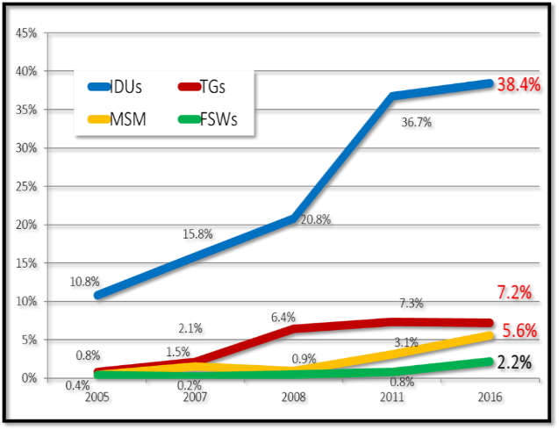
Pakistan has an estimated 150,000 people living with HIV in the country of which approximately 75,000 of the PLHIV are in Punjab, 60,000 in Sindh and around 15000 of the PLHIV are based in KPK and Baluchistan.

The HIV epidemic in the country is concentrated in key populations namely: people who inject drugs (PWID = 38.4%), male, female and transgender sex workers (MSW = 5.6%, FSW = 2.2% & TGSW = 7.5%), men who have sex with men (MSM = 5.4%) and transgenders (TG = 7.1%). The progression of HIV epidemic in Pakistan is following the Asian epidemic trend whereby HIV infection after reaching a plateau level in PWID shifts to the general population through sexual networks bridging populations.

An estimated 20,000 new HIV infections were added to the pool of PLHIV in the country of which 28% of the new infections occurred in PWID, 12% in MSM, 3% in TGs and 2% in FSW. A significant percentage of low risk males, females and clients of KPs were newly infected suggesting an increase in HIV transmission to bridging populations (spouses, partners and clients) of key populations.

INTRODUCTION:
In the background of Jalalpur Jattan case (2008), a case was filed in the Supreme Court of Pakistan for review and investigation of the outbreak. In a hearing held on August 3rd 2018 the Honourable Supreme Court constituted a Committee with the following TORs:

- Expansion of quality preventive and treatment services for Key Populations across Pakistan
- Non-stigmatised and evidence-based awareness campaign through print, electronic and social media
- Enabling environment in the light of basic human rights implementation
- To strengthen the mechanism of monitoring and evaluation of HIV services, preventive services as well as curative services and care.
- To review all the Provincial AIDS Strategy and set recommendations.

The nine-member committee is headed by the National Programme Manager, NACP and includes Provincial AIDS Control Program Managers, APLHIV, Nai-Zindagi, CSOs members and three UN agencies including UNAIDS, WHO and UNDP as co-opted members.

In a meeting held on 20th August it was decided to populate a matrix against each point of term of reference with gaps and recommendation with timelines and responsibilities to address the reoccurrence of such grave epidemiological issues in the country.

National HIV Response
Under the auspices of the Ministry of National Health Services, Regulation and Coordination (MoNHSR&C) the National AIDS Control Program (NACP) is spearheading the National HIV response in the country. NACP is primarily responsible for providing free of cost anti-retroviral treatment to people living with HIV (PLHIV) in addition to care, support and preventive services to key populations. Under the devolved health setup (post 18th Amendment) the role of NACP has been to coordinate the national response, strategic planning, policy making, program implementation and providing technical assistance to strengthen the capacities of the provinces.

To date the National AIDS Control Programme (NACP) continues to provide free of cost HIV treatment and diagnostic services through 33 HIV treatment centres (adult and paediatric) across the country. Till December 2017, the NACP provided comprehensive care and support services via 21 Community Home based Care (CHBC) Sites to the marginalized HIV infected individuals and their family members in the form of food and nutritional support, school support, empowerment/ employment support, emergency medical support and travel support to ART centres to get live-saving antiretroviral medicines. Another salient feature of the CHBC model was its outreach and active case identification followed by linkages to respective ART centres for further case management. In light of update epidemiological evidence, in 2018 NACP has started implementing a Key Population specific community-based HIV Prevention Model for a high impact targeted impact to curb the incidence of new infections and halt HIV transmission.

Gaps | Recommendations | Responsibilities and Timelines | Cross Cutting Recommendations
TOR-I: REVIEW ALL PROVINCIAL (PLUS PASIII 2017-2021) & SET RECOMMENDATIONS
TOR-II: EXPANSION OF QUALITY PREVENTION & TREATMENT SERVICES FOR KEY POPULATION ACROSS PAKISTAN
Low coverage of prevention and testing programmes (among key populations) | - Uninterrupted HIV prevention and treatment services shall be provided to those in need.  - Resources should be tapped to address the gaps in services provision.. | NACP & PACPs by Last quarter of 2018 and 1st quarter of 2019 before next PC1 development at federal and provincial level | - Quarterly 02 days programme meetings where federal and provincial programmes along with CSOs, UN partners can review progress on targets and service delivery  - Rigorous monitoring of Pakistan and Provincial AIDS Strategies are required with operation timelines including communities and APLHIV so that targets are met to achieve three 90s.  - Technical Advisory Committee on HIV and AIDS (TACA) should be revived  - Provincial Task Forces on HIV should be made functional
Barriers to uptake of HIV prevention, treatment and retention should be addressed. | - Opiate Substitution Therapy (OST) shall be introduced as a Harm Reduction service for people who inject drugs (PWID are considered to be the drivers of HIV transmission).  - HIV treatment centers should be decentralized to increase HIV treatment coverage.  - Linkages between the PLHIV communities and health care providers should be strengthened to increase receptiveness to HIV preventive and treatment services. | NACP & PACPs, APLHIV, CSOs along with technical support of UN partners at earliest basis
HIV prevention services for key populations are limited to select cities and populations. In Punjab since 2016 these services (including HIV Prevention and testing services in KPs, care and support services for PLHIV) are not available. | Service delivery packages approved under the PC1s need to implemented and complemented by donor support. | PACPs to operationalize PC1 and its ongoing process
Delayed release of PC-1. | - Arrangements shall be made to ensure the timely release, appropriate and effective utilization of PC-1 funds.
TOR 3: ENABLING ENVIRONMENT IN THE LIGHT OF BASIC HUMAN RIGHTS IMPLEMENTATION
TOR 4: NON-STIGMATISED & EVIDENCES BASED AWARENESS CAMPAIGN THROUGH PRINT ELECTRONIC & SOCIAL MEDIA
The IBBS 2016-2017 has rated Stigma & Discrimination against Key Population as very high (>50%). | - Framework for reduction of Stigma and Discrimination shall be developed supported by Ethical committees at service delivery points. | - NACP & PACPs APLHIV, CSOs, through technical support of UN partners by Last quarter of 2018  - NACP & PACPs APLHIV, CSOs, through technical support of UN partners by 1st quarter of 2019.
Lack of effective HIV legislation and implementation | - Passage of HIV Bills under review should be expedited and implementation ensured. | NACP & PACPs through APLHIV, CSOs, technical support of UN partners between last and 1st quarter of 2019
Lack of advocacy and HIV awareness | - Media should be engaged as an effective HIV advocacy and awareness tool.  - Across the board engagement of stakeholders for advocacy and creating HIV awareness should be ensured. | NACP, PACPs, APLHIV, CSOs, through technical support of UN partners between last and 1st quarter of 2019  NACP, PACPs, APLHIV, CSOs, through technical support of UN partners between last and 1st quarter of 2019
TOR 5: STRENGTHEN THE MECHANISM OF MONITORING AND EVALUATION OF HIV SERVICES, PREVENTION SERVICES AS WELL AS CURATIVE SERVICE AND CARE
Weak monitoring and evaluation system | - Robust national and provincial M&E systems shall be introduced for stringent monitoring of HIV prevention and treatment services and resources with gap identification and mitigation.  - A national database shall be developed to document and record HIV services provision by all public and private institutions and organizations. | NACP, PACP, APLHIV through technical support of UN partners between 2018 and 1st quarter of 2019

Spectrum-2017
IBBS-2016
AEM-2017

